Blinkit Analysis
- See all the data imported:
SELECT * FROM blinkit_data;
- DATA CLEANING:
Cleaning the Item_Fat_Content field ensures data consistency and accuracy in analysis. The presence of multiple variations of the same category (e.g., LF, low fat vs. Low Fat) can cause issues in reporting, aggregations, and filtering. By standardizing these values, we improve data quality, making it easier to generate insights and maintain uniformity in our datasets.
Make disable the SQL safe updates before updating the table to avoid any errors.
SET SQL_SAFE_UPDATES=0;

UPDATE blinkit_data
SET Item_Fat_Content =
CASE
WHEN Item_Fat_Content IN ('LF', 'low fat') THEN 'Low Fat'
WHEN Item_Fat_Content = 'reg' THEN 'Regular'
ELSE Item_Fat_Content
END;
After executing this query check the data has been cleaned or not using below query
SELECT DISTINCT(Item_Fat_Content) from blinkit_data;
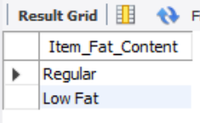

A. KPI’s
1. TOTAL SALES:
SELECT CONCAT(CAST(SUM(Total_Sales)/1000000 AS
DECIMAL(10,2)),' M') AS Total_Sales_in_Millions FROM blinkit_data;
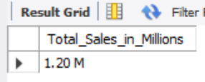
2. AVERAGE SALES
SELECT CAST(AVG(Total_Sales) AS DECIMAL(10,2)) AS AVG_Sales FROM blinkit_data;
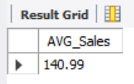
3. NO OF ITEMS
SELECT COUNT(*) AS No_of_Orders FROM blinkit_data;
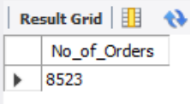
4. AVG RATING
SELECT CAST(AVG(Rating) AS DECIMAL(10,2)) AS AVG_Rating FROM blinkit_data;
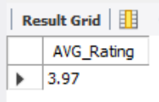

B. Total Sales by Fat Content:
SELECT Item_Fat_Content,
CONCAT(CAST(SUM(Total_Sales)/1000 AS DECIMAL(10,2)),' K') AS Total_Sales_in_Thousands
FROM blinkit_data
GROUP BY Item_Fat_Content
ORDER BY Total_Sales_in_Thousands DESC;
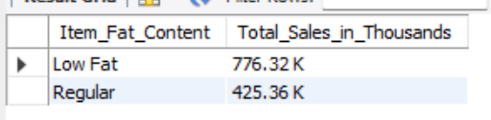
C. Total Sales by Item Type
SELECT Item_Type,
CAST(SUM(Total_Sales)/1000 AS DECIMAL(10,2)) AS Total_Sales_in_Thousands
FROM blinkit_data
GROUP BY Item_Type
ORDER BY Total_Sales_in_Thousands DESC;
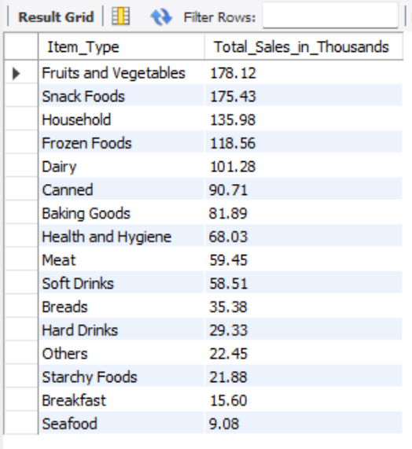
D. Fat Content by Outlet for Total Sales
SELECT
Outlet_Location_Type,
CAST(SUM(CASE WHEN Item_Fat_Content = 'Low Fat' THEN Total_Sales ELSE 0 END)/1000 AS DECIMAL(10,2)) AS Low_Fat_Sales_in_Thousands,
CAST(SUM(CASE WHEN Item_Fat_Content = 'Regular' THEN Total_Sales ELSE 0 END)/1000 AS DECIMAL(10,2)) AS Regular_Sales_in_Thousands
FROM blinkit_data
GROUP BY Outlet_Location_Type
ORDER BY Outlet_Location_Type;

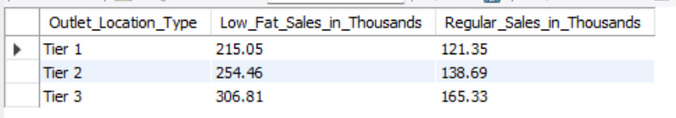
E. Total Sales by Outlet Establishment
SELECT Outlet_Establishment_Year, CAST(SUM(Total_Sales) AS DECIMAL(10,2)) AS Total_Sales_in_Thousands
FROM blinkit_data
GROUP BY Outlet_Establishment_Year
ORDER BY Outlet_Establishment_Year;

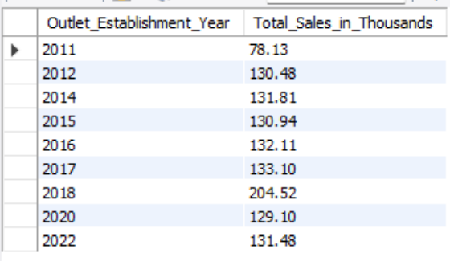

F. Percentage of Sales by Outlet Size
SELECT
Outlet_Size,
CAST(SUM(Total_Sales)/1000 AS DECIMAL(10,2)) AS Total_Sales_in_Thousands,
CAST((SUM(Total_Sales) * 100.0 / SUM(SUM(Total_Sales)) OVER()) AS DECIMAL(10,2)) AS Sales_Percentage
FROM blinkit_data
GROUP BY Outlet_Size
ORDER BY Total_Sales_in_Thousands DESC;

Query Explanation:
Outlet_Size: This column represents the size category of the outlet (e.g., Small, Medium, Large).
CAST(SUM(Total_Sales) AS DECIMAL(10,2)) AS Total_Sales:
- SUM(Total_Sales): Calculates the total sales for each Outlet_Size.
- CAST(... AS DECIMAL(10,2)): Formats the resulting sum to a decimal number with two decimal places for precision.
CAST((SUM(Total_Sales) * 100.0 / SUM(SUM(Total_Sales)) OVER()) AS DECIMAL(10,2)) AS Sales_Percentage:
- SUM(Total_Sales) * 100.0: Multiplies the total sales of the current Outlet_Size by 100 to prepare for percentage calculation.
- SUM(SUM(Total_Sales)) OVER():
  - SUM(Total_Sales): Within the GROUP BY context, this computes the total sales for each Outlet_Size.
  - SUM(... ) OVER(): The outer SUM combined with the OVER() clause calculates the grand total of all Total_Sales across all outlet sizes without collapsing the result set.
- SUM(Total_Sales) * 100.0 / SUM(SUM(Total_Sales)) OVER(): Divides the total sales of the current Outlet_Size by the grand total sales and multiplies by 100 to get the percentage contribution of each outlet size to the overall sales.
- CAST(... AS DECIMAL(10,2)): Formats the resulting percentage to two decimal places.

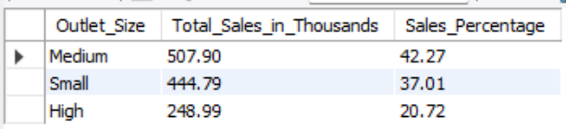

G. Sales by Outlet Location
SELECT Outlet_Location_Type, CAST(SUM(Total_Sales)/1000 AS DECIMAL(10,2)) AS Total_Sales_in_Thousands
FROM blinkit_data
GROUP BY Outlet_Location_Type
ORDER BY Total_Sales_in_Thousands DESC;
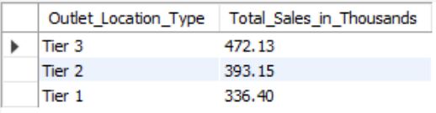

H. All Metrics by Outlet Type:
SELECT Outlet_Type,
CAST(SUM(Total_Sales)/1000 AS DECIMAL(10,2)) AS Total_Sales_in_Thousands,
CAST(AVG(Total_Sales) AS DECIMAL(10,0)) AS Avg_Sales,
COUNT(*) AS No_Of_Items,
CAST(AVG(Rating) AS DECIMAL(10,2)) AS Avg_Rating,
CAST(AVG(Item_Visibility) AS DECIMAL(10,2)) AS Item_Visibility
FROM blinkit_data
GROUP BY Outlet_Type
ORDER BY Total_Sales_in_Thousands DESC;

